-- HANDS-ON 2

-- Task 1: Insert, Update and Delete Data
use college_db;

-- INSERT SAMPLE DATA : Departments
insert into departments (dept_name, head_of_dept, budget) values
('Computer Science', 'Dr. Ramesh Kumar', 850000.00),
('Electronics', 'Dr. Priya Nair', 620000.00),
('Mechanical', 'Dr. Suresh Iyer', 540000.00),
('Civil', 'Dr. Ananya Sharma', 430000.00);

-- Students
insert into students
(first_name, last_name, email, date_of_birth, department_id, enrollment_year) values
('Arjun', 'Mehta', 'arjun.mehta@college.edu', '2003-04-12', 1, 2022),
('Priya', 'Suresh', 'priya.suresh@college.edu', '2003-07-25', 1, 2022),
('Rohan', 'Verma', 'rohan.verma@college.edu', '2002-11-08', 2, 2021),
('Sneha', 'Patel', 'sneha.patel@college.edu', '2004-01-30', 3, 2023),
('Vikram', 'Das', 'vikram.das@college.edu', '2003-09-14', 1, 2022),
('Kavya', 'Menon', 'kavya.menon@college.edu', '2002-05-17', 2, 2021),
('Aditya', 'Singh', 'aditya.singh@college.edu', '2004-03-22', 4, 2023),
('Deepika', 'Rao', 'deepika.rao@college.edu', '2003-08-09', 1, 2022);

-- Courses
insert into courses
(course_name, course_code, credits, department_id) values
('Data Structures & Algorithms', 'CS101', 4, 1),
('Database Management Systems', 'CS102', 3, 1),
('Object Oriented Programming', 'CS103', 4, 1),
('Circuit Theory', 'EC101', 3, 2),
('Thermodynamics', 'ME101', 3, 3);

-- Enrollments
insert into enrollments
(student_id, course_id, enrollment_date, grade) values
(1, 1, '2022-07-01', 'A'),
(1, 2, '2022-07-01', 'B'),
(2, 1, '2022-07-01', 'B'),
(2, 3, '2022-07-01', 'A'),
(3, 4, '2021-07-01', 'A'),
(4, 5, '2023-07-01', NULL),
(5, 1, '2022-07-01', 'C'),
(5, 2, '2022-07-01', 'A'),
(6, 4, '2021-07-01', 'B'),
(7, 5, '2023-07-01', NULL),
(8, 1, '2022-07-01', 'A'),
(8, 3, '2022-07-01', 'B');

-- Professors
insert into professors
(prof_name, email, department_id, salary) values
('Dr. Anand Krishnan', 'anand.k@college.edu', 1, 95000.00),
('Dr. Meena Pillai', 'meena.p@college.edu', 1, 88000.00),
('Dr. Sunil Rajan', 'sunil.r@college.edu', 2, 82000.00),
('Dr. Latha Gopal', 'latha.g@college.edu', 3, 79000.00),
('Dr. Kartik Bose', 'kartik.b@college.edu', 4, 76000.00);

select count(*) from departments;

select count(*) from students;

select count(*) from courses;

select count(*) from enrollments;

select count(*) from professors;
Output:

-- Insert two additional students
insert into students
(first_name, last_name, email, date_of_birth, department_id, enrollment_year)
values
('Rahul', 'Sharma', 'rahul.sharma@college.edu', '2003-06-18', 2, 2022),
('Neha', 'Reddy', 'neha.reddy@college.edu', '2004-02-10', 3, 2023);

select count(*) as total_students
from students;
Output:
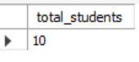

-- Update grade
update enrollments
set grade = 'B'
where student_id = 5
and course_id = 1;

-- Delete enrollments with NULL grade
select *
from enrollments
where grade is null;

-- Verify
set sql_safe_updates = 0;
delete from enrollments
where grade is null;

select count(*) as total_enrollments
from enrollments;

-- Task 2: Single Table Queries and Filtering
USE college_db;

-- Retrieve all students enrolled in 2022
-- Ordered by last_name alphabetically
select *
from students
where enrollment_year = 2022
order by last_name asc;
Output:
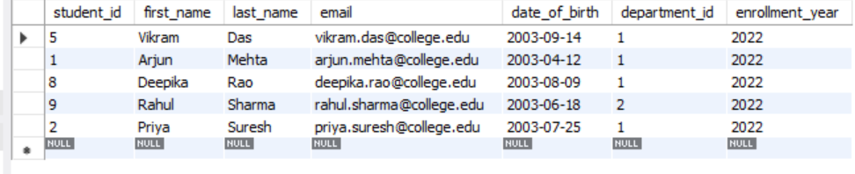

-- Find courses with more than 3 credits
select *
from courses
where credits > 3
order by credits desc;
Output:
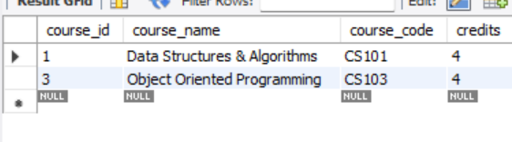

-- Professors with salary between 80000 and 95000
select *
from professors
where salary between 80000 and 95000;
Output:
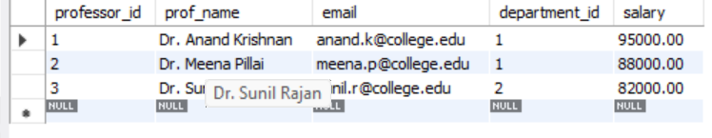
-- Students whose email ends with @college.edu
select *
from students
where email like '%@college.edu';
Output:
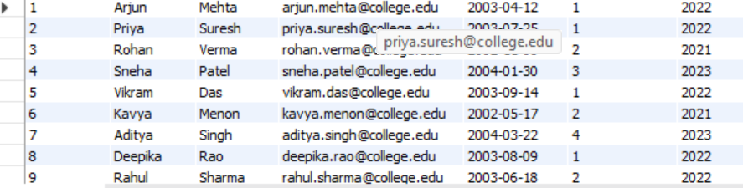

-- Count total students per enrollment_year
select enrollment_year,
count(*) as total_students
from students
group by enrollment_year;
Output:
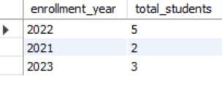

-- Task 3: Multi-Table Joins
use college_db;

-- Student full name with department name
select
concat(s.first_name,' ',s.last_name) as student_name,
d.dept_name
from students s
join departments d
on s.department_id = d.department_id;
Output:
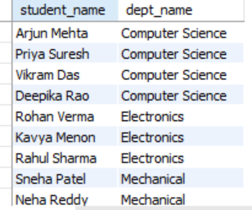

-- Enrollment with student name and course name
select
concat(s.first_name,' ',s.last_name) as student_name,
c.course_name,
e.grade
from enrollments e
join students s
on e.student_id = s.student_id
join courses c
on e.course_id = c.course_id;

-- Students NOT enrolled in any course
-- LEFT JOIN + IS NULL
select
s.student_id,
concat(s.first_name,' ',s.last_name) as student_name
from students s
left join enrollments e
on s.student_id = e.student_id
where e.student_id is null;
OUTPUT:
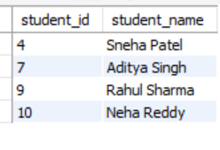
-- Every course with number of enrolled students
select
c.course_name,
count(e.student_id) as enrollment_count
from courses c
left join enrollments e
on c.course_id = e.course_id
group by c.course_id, c.course_name;

Output:
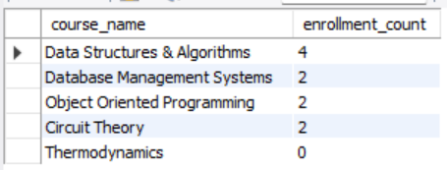

-- Departments with professors and salaries
-- Include departments without professors
select
d.dept_name,
p.prof_name,
p.salary
from departments d
left join professors p
on d.department_id = p.department_id;
Output:
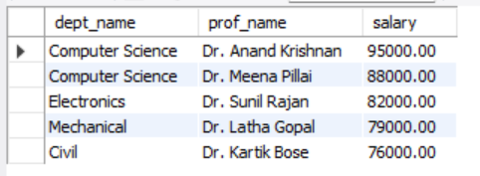

-- Task 4: Aggregations and Grouping
use college_db;

-- Total number of enrollments per course
select
c.course_name,
count(e.student_id) as enrollment_count
from courses c
left join enrollments e
on c.course_id = e.course_id
group by c.course_id, c.course_name;
Output:
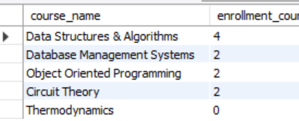
-- Average salary of professors per department
-- Round to 2 decimal places
select
d.dept_name,
round(avg(p.salary),2) as average_salary
from departments d
left join professors p
on d.department_id = p.department_id
group by d.department_id, d.dept_name;

Output:
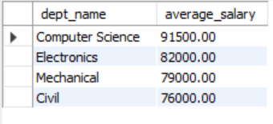

-- Departments where budget exceeds 600000
select
dept_name,
budget
from departments
where budget > 600000;
Output:
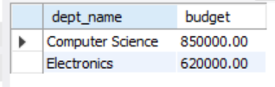
-- Grade distribution for course CS101
select
e.grade,
count(*) as total
from enrollments e
join courses c
on e.course_id = c.course_id
where c.course_code = 'CS101'
group by e.grade;
Output:
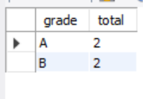
-- Departments where more than 2 students enrolled
-- Using HAVING
select
d.dept_name,
count(e.student_id) as total_enrollments
from departments d
join students s
on d.department_id = s.department_id
join enrollments e
on s.student_id = e.student_id
group by d.department_id, d.dept_name
having count(e.student_id) > 2;
Output:
